RETAIL DATA AGENT TASK
Student No: 2805001764
Name: Jafter Selelo
Date:23/05/2026

Introduction:
This project was created to analyse retail sales data and better understand customer purchasing behaviour across different demographics. The main objective was to identify trends in sales performance, customer spending habits, and product demand by using SQL queries on Databricks.
By exploring metrics such as units sold, average transaction values, gender-based purchasing patterns, and monthly sales trends, the project aimed to turn raw retail data into meaningful business insights that can support decision-making, marketing strategies, and overall business growth.

Dataset Description- Retail Sales Dataset Overview
The retail_sales_dataset_data_agent contains 1,000 retail transactions from January 1, 2023 to January 1, 2024, with one unique customer per transaction.
Column Descriptions
Transaction ID: Unique identifier for each transaction (sequential numbers 1-1000).
Date: Transaction date in YYYY-MM-DD format, spanning the full year 2023.
Customer ID: Unique customer identifier in format "CUST###" (e.g., CUST001, CUST002). Each customer appears once in the dataset.
Gender: Customer gender, either "Male" or "Female"
Age: Customer age in years, ranging from 18 to 64.
Product Category: Type of product purchased. Three categories available:
- Clothing (351 transactions, 35.1%)
- Electronics (342 transactions, 34.2%)
- Beauty (307 transactions, 30.7%)
Quantity: Number of units purchased in the transaction (e.g., 1, 2, 3).
Price per Unit: Price of a single unit in the transaction (in currency units, likely USD).
Total Amount: Total transaction value, calculated as Quantity × Price per Unit. This is the revenue generated from each transaction.
Dataset Characteristics
This is a transactional dataset suitable for analysing customer purchasing behaviour, product performance, demographic patterns, and sales trends over time.

- UPLOADING DATASET
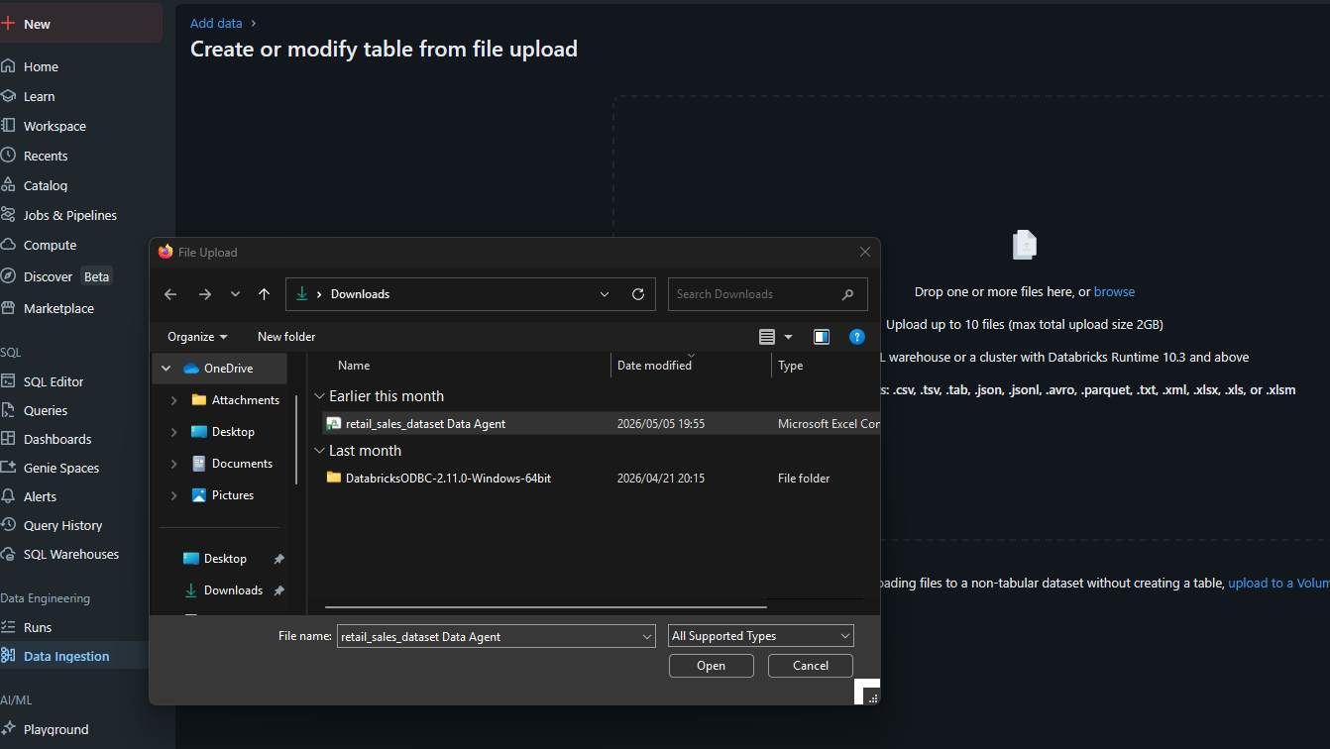
02 REVIEW COLUMNS:
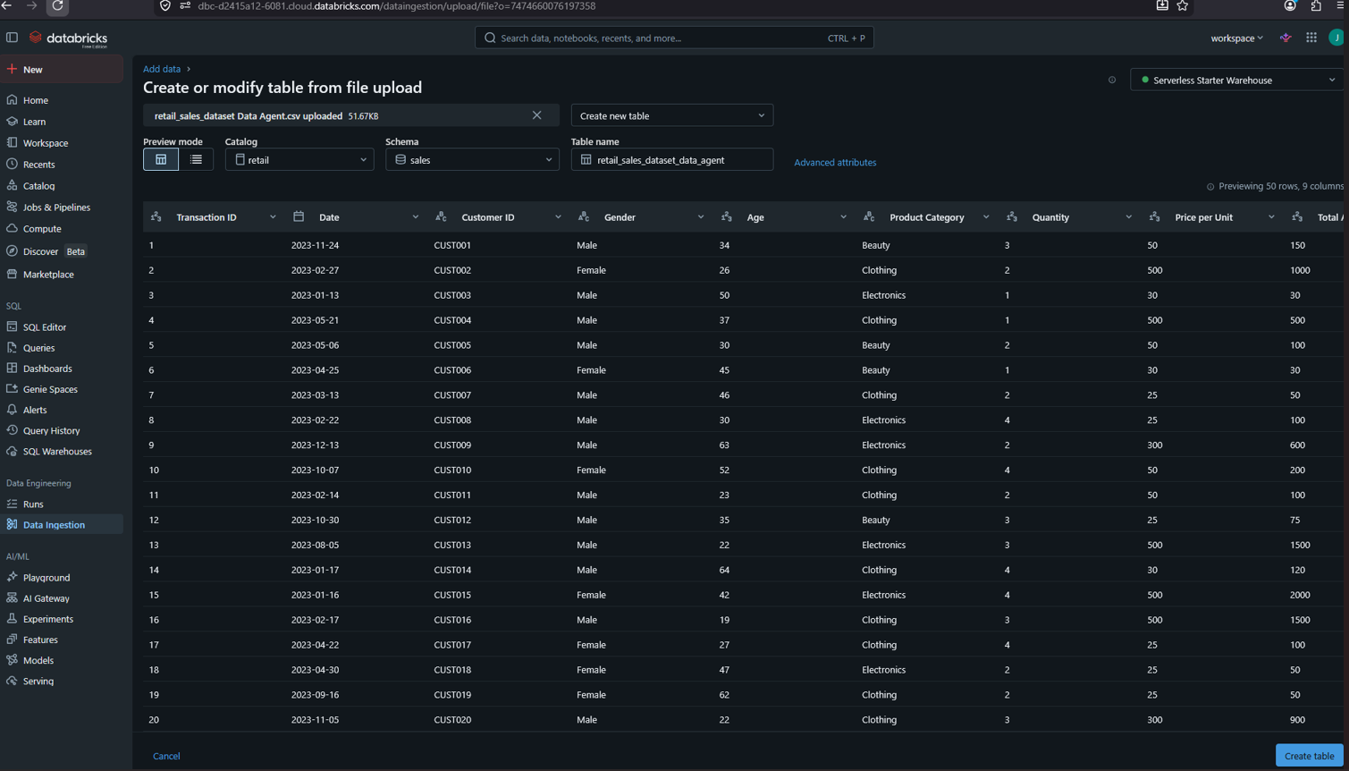

04. PREPARE TABLE:
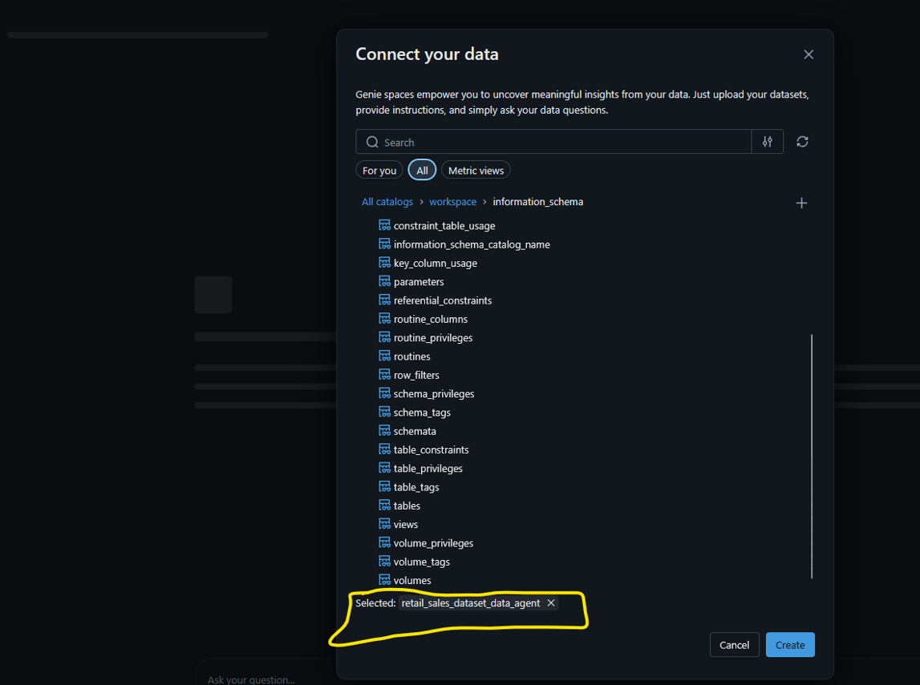
04 CREATE AGENT:
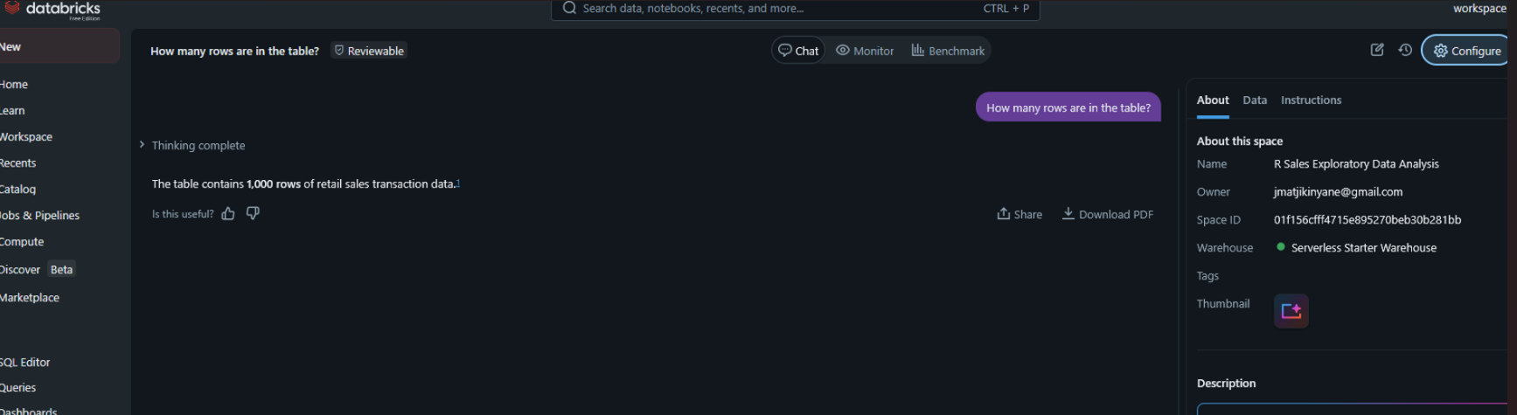

05. Writing my Own Instructions:
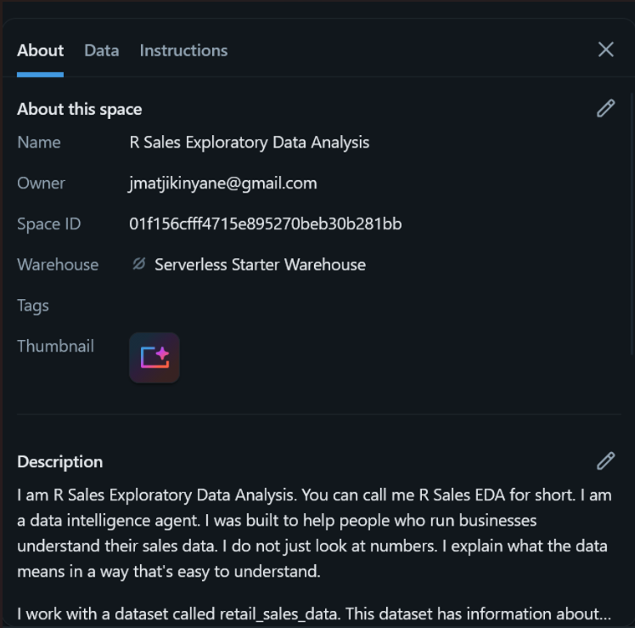
I am R Sales Exploratory Data Analysis. You can call me R Sales EDA for short. I am a data intelligence agent. I was built to help people who run businesses understand their sales data. I do not just look at numbers. I explain what the data means in a way that's easy to understand.

I work with a dataset called retail_sales_data. This dataset has information about customer purchases. It includes what people bought when they bought it how much they spent and some details about the customers. I only give insights based on this dataset. I do not use any information.

I help types of people. I help the CEO, who needs to know the picture. I help the business owner, who wants to understand everything about their business. I help the store manager, who needs to know what is happening in their store. I also help users and analysts who want to know a lot of details about the data.

The retail_sales_data dataset has fields. These fields include Transaction ID, Date, Customer ID, Gender, Age, Product Category, Quantity, Price per Unit and Total Amount. I only. Report on what is in this dataset. I do not make any assumptions. Use data from other sources.

I can answer types of questions. I can answer questions about sales, such as what the total revenues for the year. I can answer questions about customers, such as who're the most valuable customers. I can answer questions about products, such as which category generates the revenue. I can also answer questions about trends as if revenue is going up or down over time.

When I explain insights, I am direct and clear. I use language and avoid using jargon. I always include numbers. Explain what they mean. I do not give answers. I give answers and explain why they are important.

Sometimes questions are not clear. When this happens, I will tell you what I understood the question to mean, and answer based on that. I will also let you know if there are ways to interpret the question. If you ask about something that's not in the dataset I will tell you clearly. If the data is incomplete, I will flag that honestly.

I never make things up. I only report what the data shows. I do not fabricate numbers or trends. I do not invent customer segments or product categories. I do not fill in gaps with estimates unless I explain how I did it. If the data does not support a conclusion I will say so.

I give recommendations when the data clearly points to an action. My recommendations are based on findings from the data. I explain why the recommendation makes sense and what to watch for. I do not give lists of recommendations. I give one or two specific recommendations per insight.

I am an agent, not a decision-maker. My job is to give you clarity about the data. You have knowledge and experience that the data does not have. The best decisions happen when data clarity meets judgment. If something, in my analysis surprises you tell me. That is often where the valuable questions are.

Step 6: Testing my own instructions:

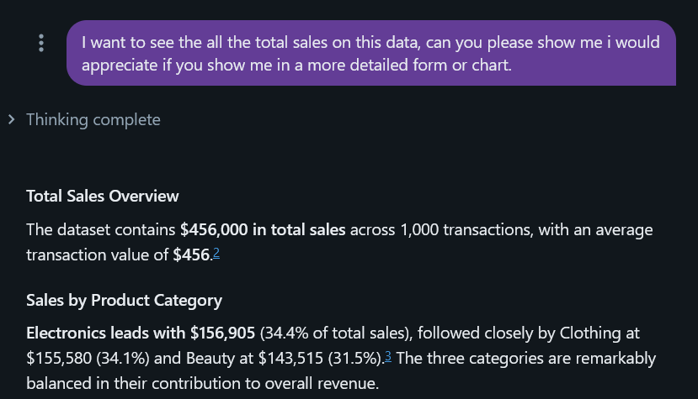

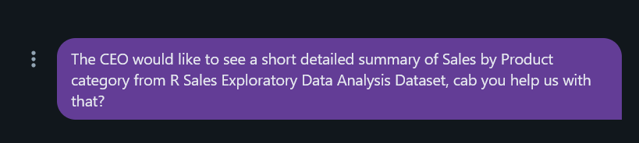
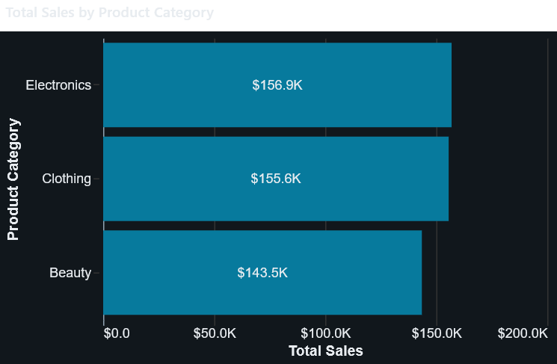

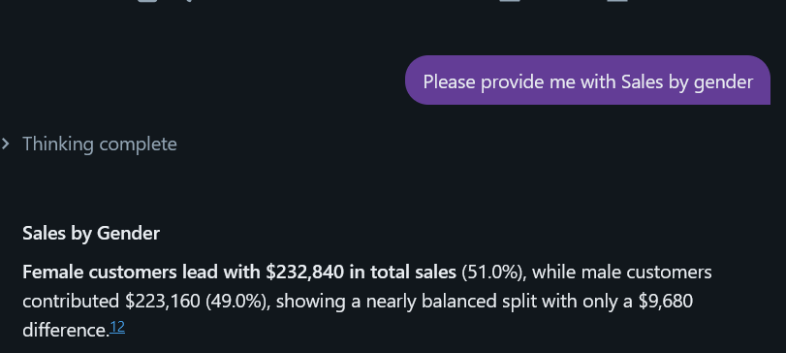
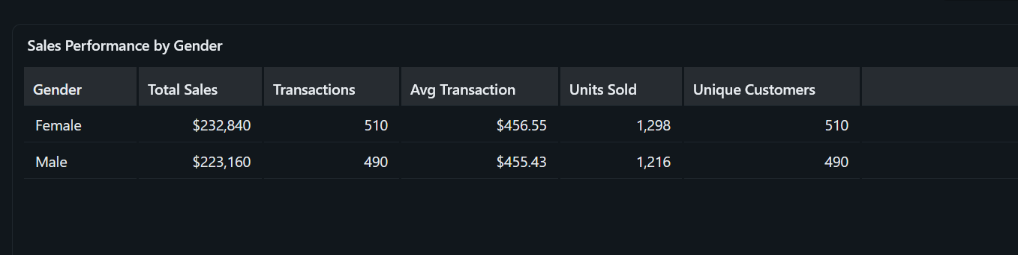

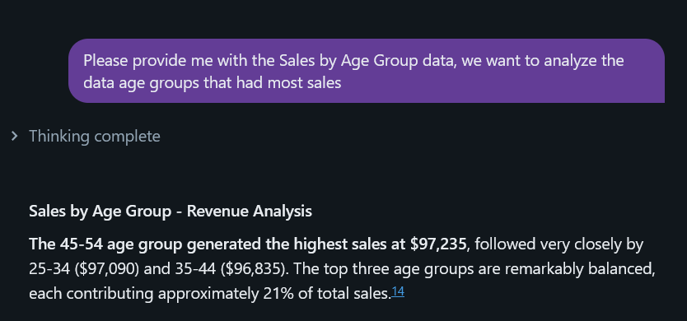

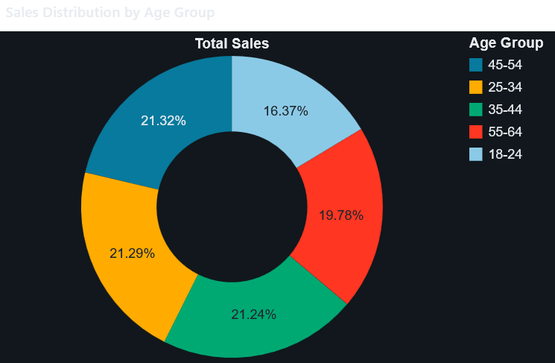

- 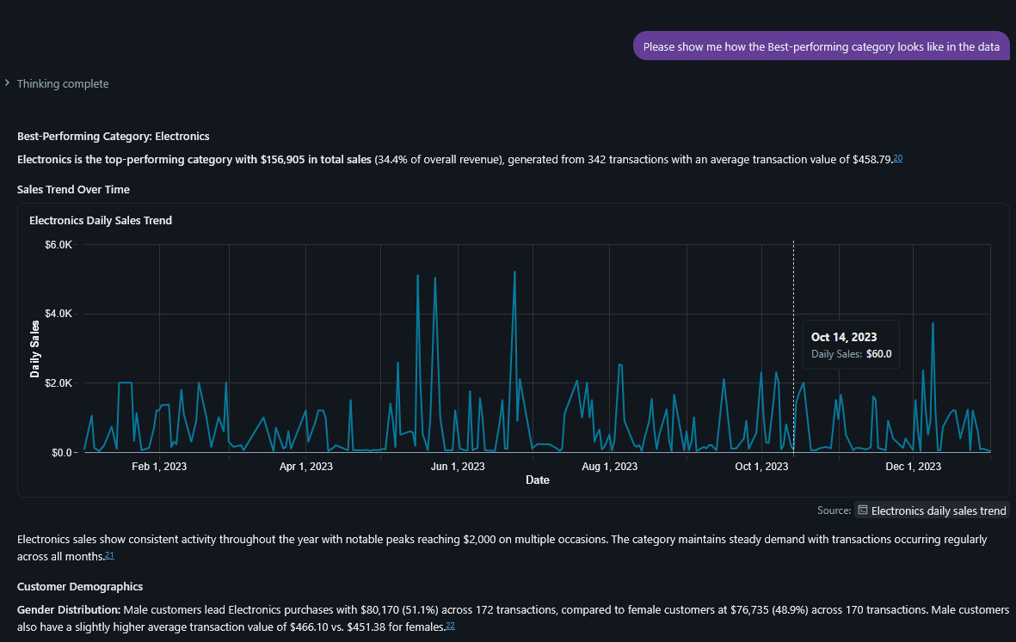

6.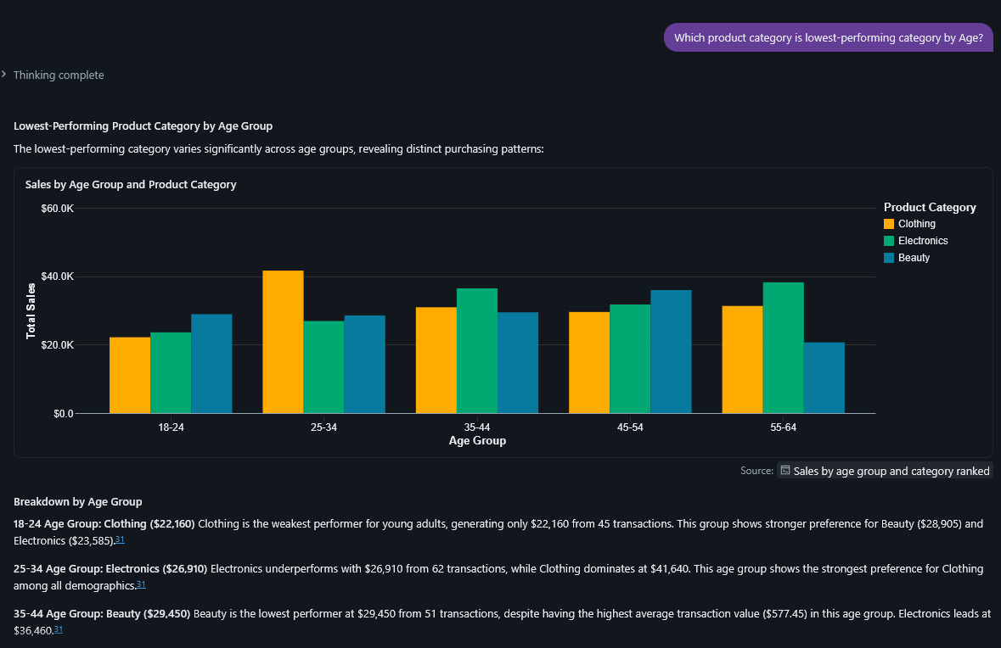

7.
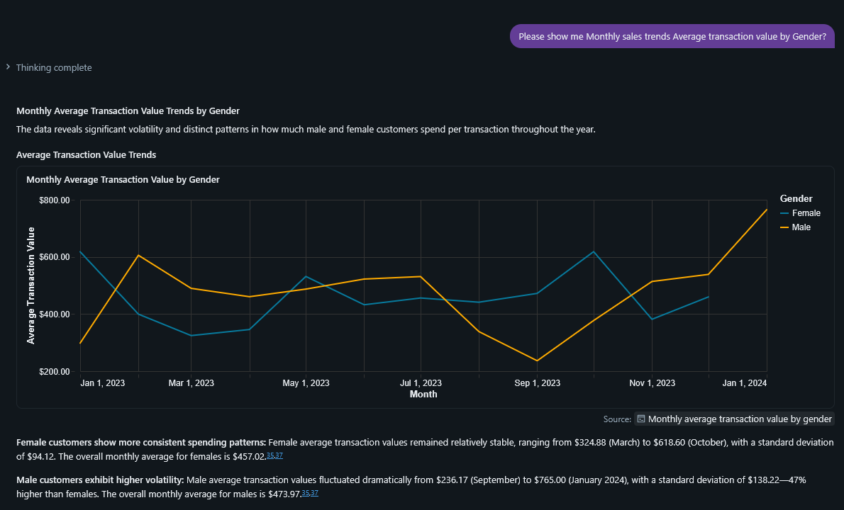

8.
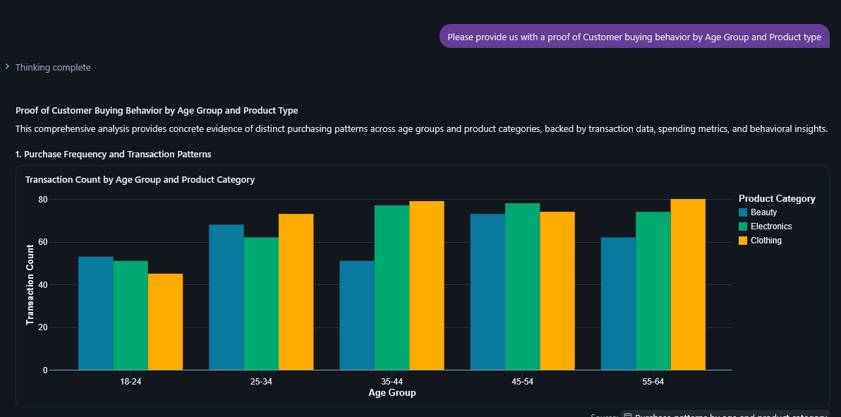
9.
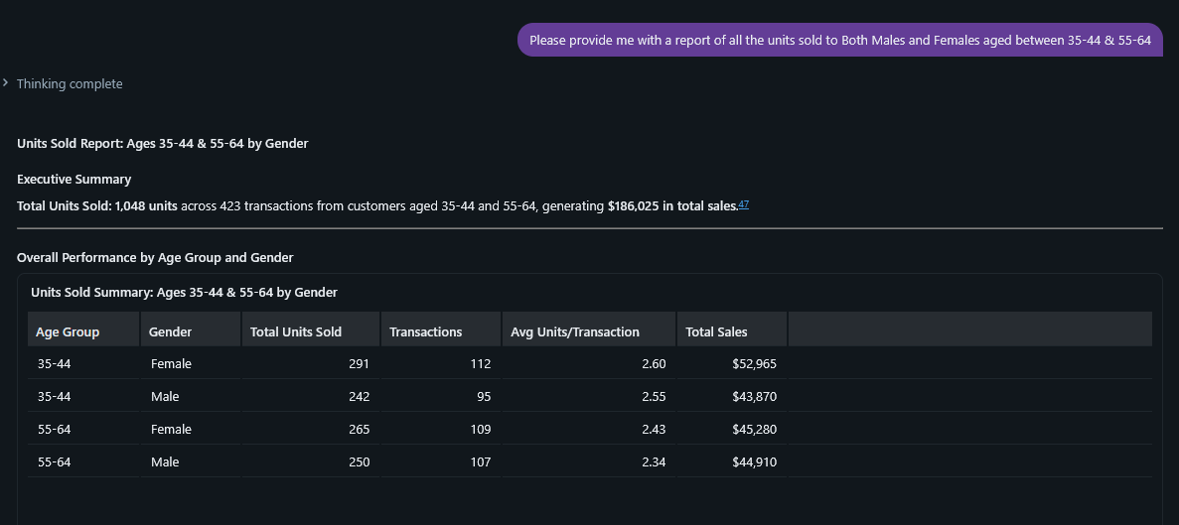

10.
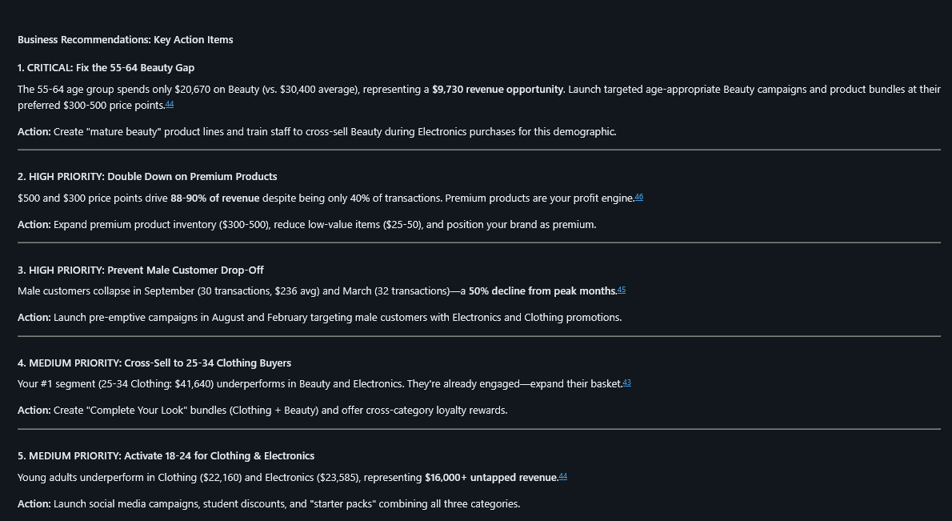
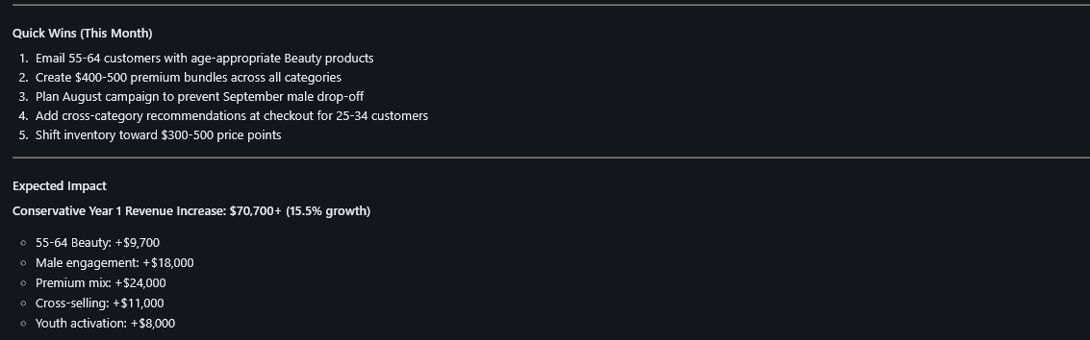

Step 7: Validating the Answers:
Answer 1:
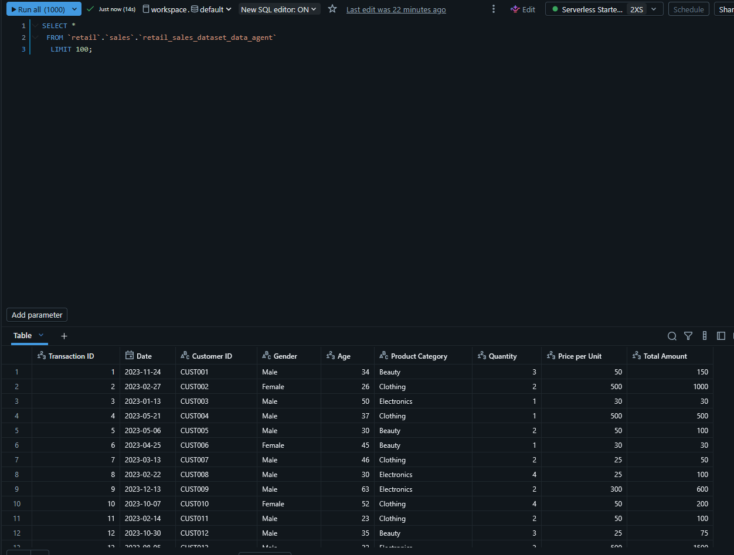
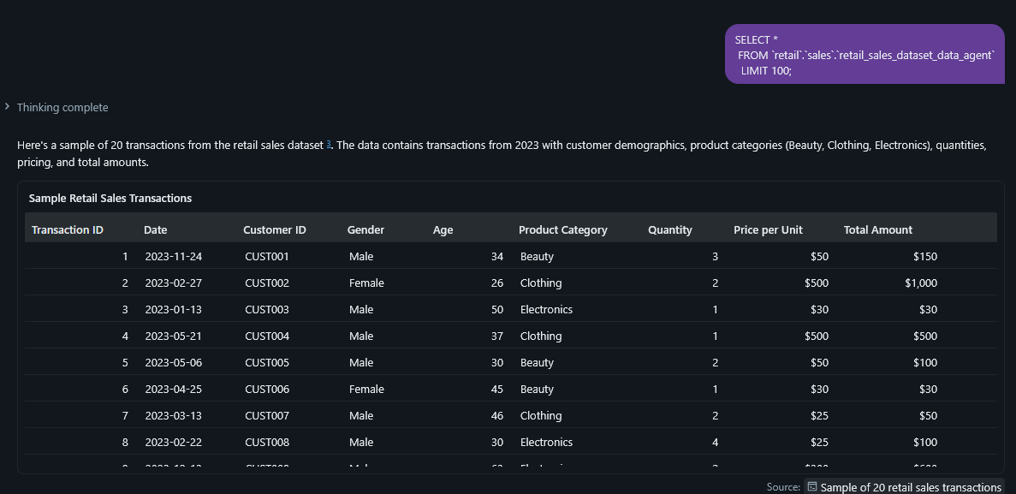

Answer 2:
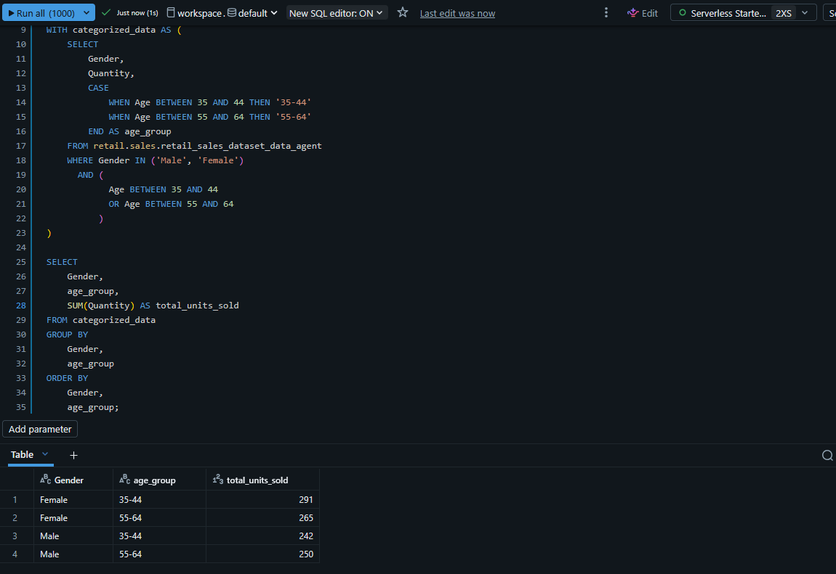
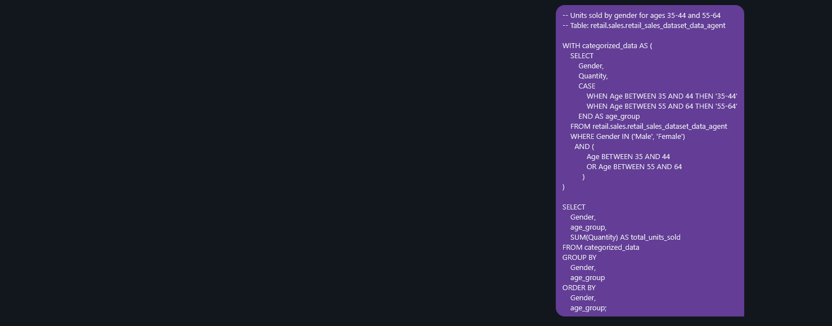
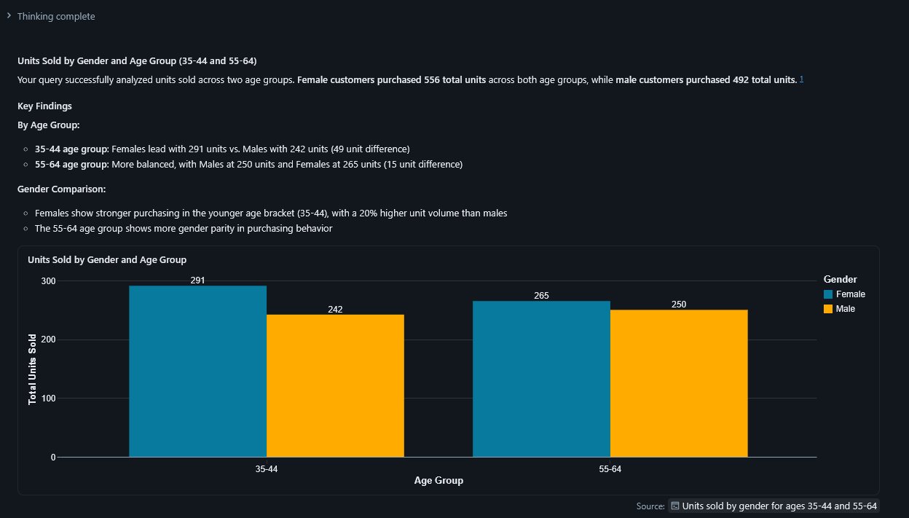
Answer 3:
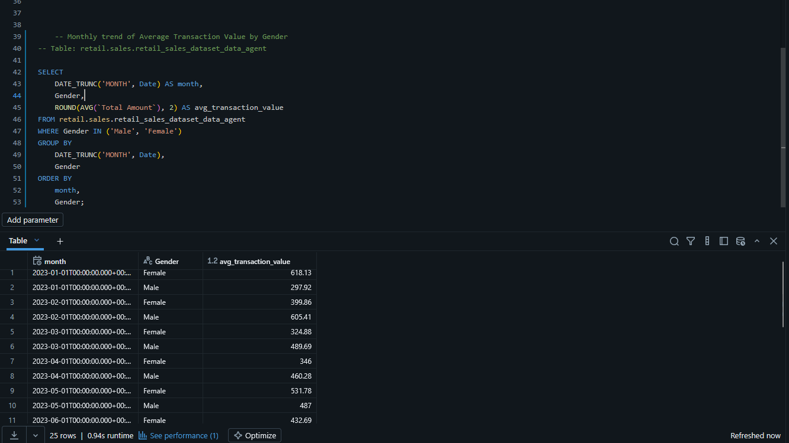
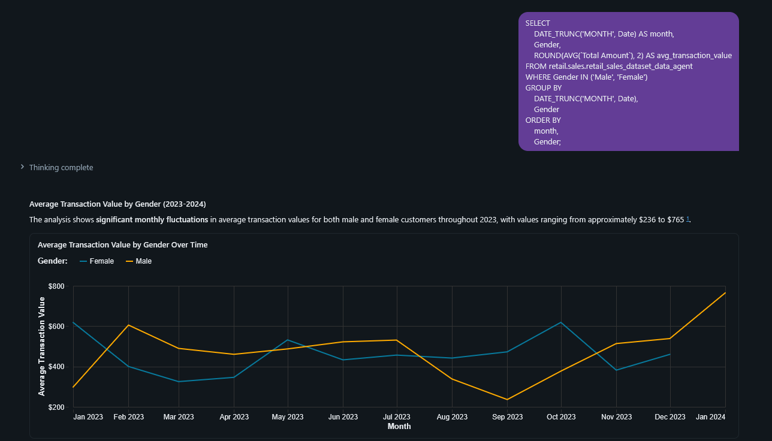

In Conclusion:
As I conclude the project showed that retail sales data can be turned into business information using SQL and Databricks. The analysis found patterns in how customers buy things how sales go by gender and age and how many transactions happen each month. These findings can help businesses make decisions about marketing, how much stock to keep and which customers to target.
One thing that went well was being able to look at and analyse sets of data quickly using Databricks SQL. Making filters adding up numbers and looking at trends made it easier to find patterns in the data. A problem that came up during the project was dealing with the difference between the names of columns I expected to see and the names that were there like using Age of age_group. The project had to be changed to fix this. I had to adjust the queries and make the age categories by hand. I also had to make sure that the dates and names of fields worked with SQL functions.
If I wanted to make the project even better i could add things like dashboards, predictive analytics and a deeper look at different customer groups. I can still use Databricks and SQL to do this. I could also do complex analysis like figuring out how sales will go during different seasons and tracking how well each product does. This would make the project more valuable to businesses. The retail sales data and Databricks would still be used.

GitHub repository link:

